**DAILY ONLINE ACTIVITIES SUMMARY**

|  |  |  |  |  |  |  |  |  |
| --- | --- | --- | --- | --- | --- | --- | --- | --- |
| **Date:** | **18-06-2020** | | | | | **Name:** | **Rani M.D** | |
| **Sem & Sec** | **VI Sem B** | | | | | **USN:** | **4AL17CS075** | |
| **Online Test Summary** | | | | | | | | |
| **Subject** | | **-** | | | | | | |
| **Max. Marks** | | **-** | | **Score** | | | **-** | |
| **Certification Course Summary** | | | | | | | | |
| **Course** | 1.Pre-Placement Training2.DA and ML workshop | | | | | | | |
| **Certificate Provider** | | | **-** | | **Duration** | | | **4hr** |
| **Coding Challenges** | | | | | | | | |
| **Problem Statement:** Write a Java program to Check if a binary tree is binary search tree or not | | | | | | | | |
| **Status:Completed** | | | | | | | | |
| **Uploaded the report in Github** | | | | | **Yes** | | | |
| **If yes Repository name** | | | | | Online activities  And <https://github.com/RaniDevaraj/Python_application_in_DA-and-ML/tree/master/DAY4> | | | |
| **Uploaded the report in slack** | | | | | **Yes** | | | |

Online Training Details:

Attended class on the topic Programming in C. [from 9am to 11am]

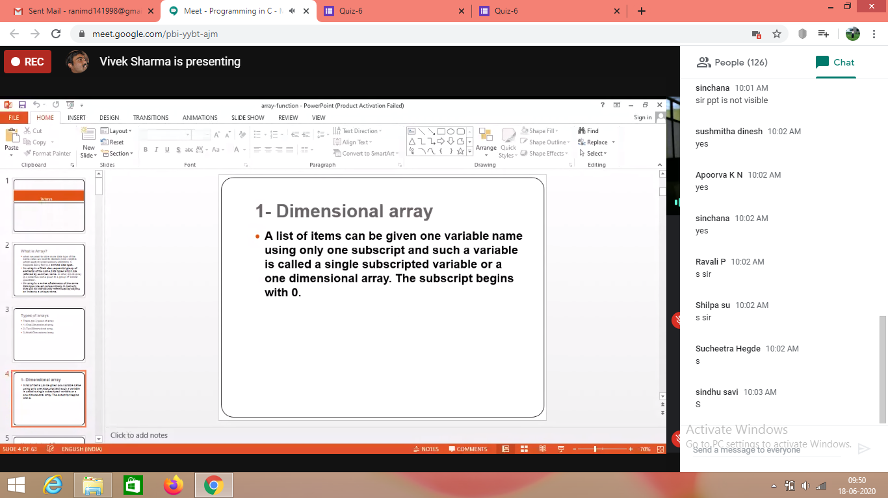

Attended Python Workshop on DA and ML. [from 11am to 1:30pm]

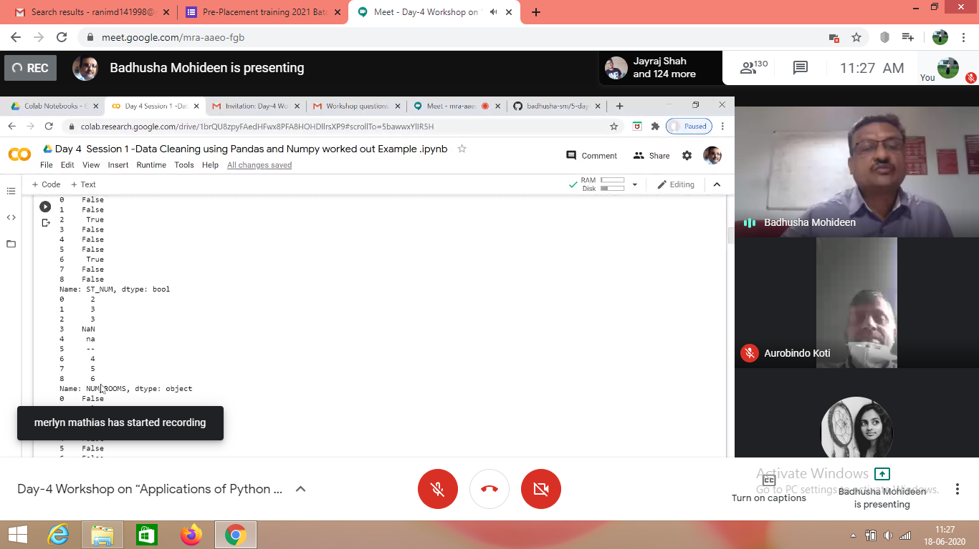

Coding Challenges Details:

## 1. Write a Java program to Check if a binary tree is binary search tree or not

